Alternate Interior Angles | The pairs of angles located inside the parallel lines (interior) and on opposite sides (alternate) of the transversal. These angles are congruent. | 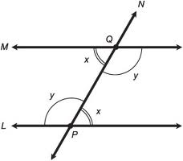
Alternate Exterior Angles | The pairs of angles located outside the parallel lines (exterior) and on opposite sides (alternate) of the transversal. These angles are congruent. | 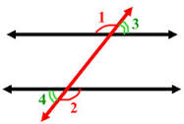
Same Side Interior Angles | The pairs of angles located inside the parallel lines (interior) and on the same side of the transversal. These angles are supplementary (they have a sum of 180°). | 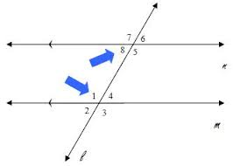
Same Side Exterior Angles | The pairs of angles located outside the parallel lines (exterior) and on the same side of the transversal. These angles are supplementary (they have a sum of 180°). | 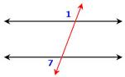
Vertical Angles | These angles are opposite of each other in the same intersection. They share the same vertex. They are congruent. | 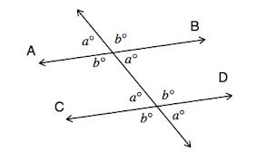
Corresponding Angles | These angles are in the same position in different intersections. If you translated one intersection to the other, the angles would correspond They are congruent. | 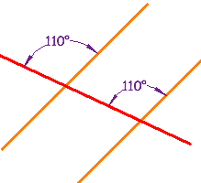
Complementary Angles | These angles have a sum of 90°. They form a right angle. | 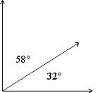
Supplementary Angles | These angles have a sum of 180°. They form a straight line. | 