2nd Semester Review 2016

Unit 7: Structure and Function of Cells

7.12C Levels of Organization

Student Expectation
The student is expected to recognize levels of organization in plants and animals, including cells, tissues, organs, organ systems, and organisms.

Key Concepts
- Key Concept 1: The organizational structure of all plants and animals can be ordered into different levels, each having specific function, beginning with the smallest, least complex structure, the cell, to tissues, organs, organ systems, to the largest, most complex structure, the organism.
- Key Concept 2: Groups of cells, the smallest units of a plant or animal, form tissues. Tissues with similar structures and functions form organs. Organ systems are the result of various organs working together. Organisms are the sum of all levels of organization operating together.

Fundamental Questions
1. What are the levels of organization in the structure of plants and animals in order from the simplest to the most
complex?
2. Why is it important to discuss levels of organization in living systems in terms of both structure and function of each level?

7.12D Plant vs. Animal Cell

Student Expectation
The student is expected to differentiate between structure and function in plant and animal cell organelles, including cell membrane, cell wall, nucleus, cytoplasm, mitochondrion, chloroplast, and vacuole.

Key Concepts
- Key Concept 1: All eukaryotic cells contain organelles. The unique structure and chemical composition of individual organelles in plant and animal cells allow them to perform distinct functions within the cell. Some organelles, like the nucleus are found in both plant and animal cells; other organelles are used to distinguish between plant and animal cells.
- Key Concept 2: Plant and animal cells of the Domain Eukarya are structurally complex, containing internal, membrane-bound organelles and a distinct nucleus that physically separates the genetic material of the cell from the all of the other parts of the cell. Both plant and animal cells have cell membranes that regulate the transfer material in and out of the cell, mitochondrion that produce energy for cell functions, and cytoplasm that surrounds the organelles within the cell itself.
- Key Concept 3: Plant cells contain several organelles not found in animal cells such as a cell wall for protection and structure and chloroplasts for photosynthesis. Another prominent organelle in plants is a large fluid-filled central vacuole which the cell uses to store water and other substances. Vacuoles can be found in some animal cells but they are not as common as in plant cells.

Fundamental Questions
- What are the relationships among cells, tissues, organs, and organ systems in plant and animal organisms?

- What is a cell membrane and what function does it serve in the cell? Is it found in plant cells, animal cells or both?

- What is a cell wall and what function does it serve in the cell? Is it found in plant cells, animal cells or both?

- What is a nucleus and what function does it serve in the cell? Is it found in plant cells, animal cells or both?

- What is cytoplasm and what function does it serve in the cell? Is it found in plant cells, animal cells or both?

- What is a mitochondrion and what function does it serve in the cell? Is it found in plant cells, animal cells or
both?

- What is a chloroplast and what function does it serve in the cell? Is it found in plant cells, animal cells or both?

- What is a vacuole and what function does it serve in a cell? Is it found in plant cells, animal cells or both?

Label each of the 8 organelles
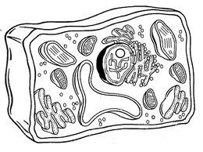
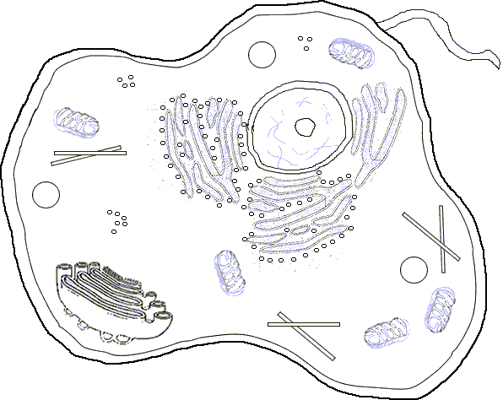

7.12EF Cell Theory

Student Expectation
The student is expected to compare the functions of a cell to the functions of organisms such as waste removal AND recognize that according to cell theory all organisms are composed of cells and cells carry on similar functions such as extracting energy from food to sustain life.

Key Concepts
- Key Concept 1: The cell theory, one of the most important core ideas in biology, states that the cell is a fundamental unit of structure, function and organization in all living organisms.
- Key Concept 2: Functions of a cell can be compared to those of an organism such as the ability to remove waste, or to obtain energy and use it to sustain life.
- Key Concept 3: Every living organism is made of one or more cells. The cell is the basic unit of structure and function and is the smallest unit that performs life functions.

Fundamental Questions
- Why is the cell theory considered a core idea in biology?

- How are the functions of a cell similar to the functions of an organism?

- How does the cell theory relate to the structure and function of cells in living organisms?

Unit 8: Structure and Function of Living Systems

7.11BC 7.12A Internal Adaptations

Student Expectation
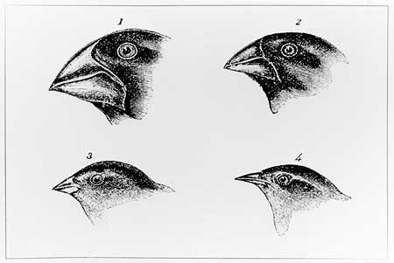
The student is expected to explain variation within a population or species by comparing external features, behaviors, or physiology of organisms that enhance their survival such as migration, hibernation, or storage of food in a bulb, identify some changes in genetic traits that have occurred over several generations through natural selection and selective breeding such as the Galapagos Medium Ground Finch (Geospiza fortis) or domestic animals, AND investigate and explain how internal structures of organisms have adaptations that allow specific functions such as gills in fish, hollow bones in birds, or xylem in plants.

Key Concepts
- Key Concept 1: Populations and species demonstrate unique variations and inherited traits which have gradually changed over time as they were passed from one generation to the next. Changes in external features, behaviors, and physiology of organisms (internal structures), through natural selection or selective breeding can enhance the survival of a species or produce desired genetic traits.
- Key Concept 2: Structures of living organisms demonstrate adaptations that allow for specific functions. Over generations, traits that enhance survival of a species are selected over those that do not.
- Key Concept 3: Populations have developed physical and behavioral adaptations that enhance their survival. For instance, some migrate, others hibernate and others may store fat and energy in order to survive a cold winter.
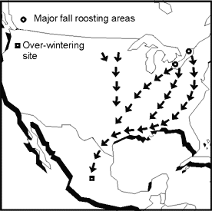
- Key Concept 4: Natural selection is possible because of genetic variation among individual organisms within a population. The occurrence of natural selection has changed nearly every species found on Earth, for example: the Galapagos Medium Ground Finch has developed a unique beak shape allowing it to fill a specific niche and improve its ability to survive.
- Key Concept 5: In selective breeding, the favorable traits to be passed on to the next generation are chosen by the breeder. Careful breeding of food crops like corn and wheat have resulted in plants that yield more food per acre. Selective breeding of domestic animals like dogs have led to incredible diversity from their wolf ancestors.
- Key Concept 6: Adaptations of structures to function are demonstrated in external features such as the long neck of a giraffe or floating lily pad leaves, and in internal structures such as the gills of a fish, the presence of hollow bones in birds, and xylem in plants.

Fundamental Questions
- How have changes in inherited traits over generations enhanced the survival of a species?

- How can structural changes over time in living organisms enhance the survival of a species?

- What are some physical and behavioral adaptations that have enhanced a species survival?

- What is natural selection and how can it change a species over time?

- How has the process of selective breeding changed food crops and domestic animals?

- How have the internal structures of organisms adapted over time to meet specific functional needs of animals?

  - What is an independent variable?

  - What is a dependent variable?

  - What is DRY MIX?

  - Label Graph

7.12B Systems of the Human Body

Student Expectations

The student is expected to identify the main functions of the systems of the human organism, including the circulatory, respiratory, skeletal, muscular, digestive, excretory, reproductive, integumentary, nervous, and endocrine systems.

Key Concepts
- Key Concept 1: Systems of the human body are structured to perform specific functions including circulation, respiration, structural support, movement, digestion, waste removal, reproduction, protection, and sensory control.
- Key Concept 2: The circulatory system circulates blood through the body, supplies cells with oxygen and nutrients and removes waste products.
- Key Concept 3: The respiratory system supplies blood with oxygen in the lungs and removes carbon dioxide.
- Key Concept 4: The skeletal system holds organs in place, provides a structural support for the body and its muscles, stores minerals and contains materials to make new blood cells.
- Key Concept 5: The muscular system allows the body to move when attached to bone, and allows movement in internal organs such as the heart and intestines.
- Key Concept 6: The digestive system converts food into simpler substances for the body to absorb as nutrients. Breakdown of food also provides energy for all bodily functions.
- Key Concept 7: The excretory system filters water and fluids from the blood while also collecting waste urine.
- Key Concept 8: The reproductive system allows humans to continue as a species by fertilizing a female ovum with a male sperm through sexual reproduction.
- Key Concept 9: The integumentary system continuously receives communication with the external environment (temperature, humidity, etc.) and protects the body’s deeper tissues. It excretes waste, helps rid the body of heat and synthesizes vitamin D.
- Key Concept 10: The nervous and endocrine systems work together and are the body’s two systems for control and communication. The nervous system sends immediate and specific information as electrical impulses. Although transmitting more slowly than the nervous system, the endocrine system sends signals in the form of hormones which control growth, reproduction and metabolism.

Fundamental Questions
- What is the function of the circulatory system?

- What is the function of the respiratory system?

- What is the function of the skeletal system?

- What is the function of the muscular system?
- What is the function of the digestive system?

- What is the function of the excretory system?

- What is the function of the reproductive system?

- What is the function of the integumentary system?

- What is the function of the nervous system?

- What is the function of the endocrine system?

Unit 9: Physical, Chemical and Energy Changes in Digestion

7.6A Organic Compounds

Student Expectation
The student is expected to identify that organic compounds contain carbon and other elements such as hydrogen, oxygen, phosphorus, nitrogen, or sulfur.

Key Concepts
- Key Concept 1: Matter has physical and chemical properties that determine the types of changes that can occur. Matter is classified as organic or inorganic based upon its chemical composition. All living and once living systems are organic and have chemical compositions that contain compounds of carbon combined with other elements.
- Key Concept 2: Organic compounds can contain a variety of elements but they always contain carbon.
- Key Concept 3: Organic compounds often contain hydrogen, oxygen, phosphorus, nitrogen and sulfur, in addition to carbon.

Fundamental Questions
- What are some common properties that characterize organic compounds as they are naturally formed and as they are changed during the digestive process in organisms?

- What element most commonly distinguishes organic compounds from inorganic compounds?

- What combination of elements commonly form organic compounds?

7.6B Physical and Chemical Changes

Student Expectations

The student is expected to distinguish between physical and chemical changes in matter in the digestive system.

Key Concepts
- Key Concept 1: Matter has physical and chemical properties that determine the types of changes that can occur. In the digestive process, organisms break down matter by both physical and chemical processes.
- Key Concept 2: Physical changes include breaking a substance into smaller size particles or changing the phase of the substance. Physical changes do not alter the identity of the substance. Examples of physical changes during digestion include teeth cutting and crushing food and churning food in the stomach.
- Key Concept 3: Evidence of a physical change in matter includes release or absorption of heat, change in particle size, or change of phase.
- Key Concept 4: A chemical change is one during which a substance is transformed into a different substance. Examples of chemical change during digestion includes the action of enzymes and digestive juices of the mouth and stomach that chemically change food particles into nutrients that the body can use.
- Key Concept 5: Evidence of a chemical change in matter includes production of a gas, color change, formation of a precipitate, change in temperature and production of light.

Fundamental Questions
- How are physical changes different from chemical changes of matter in the digestive system?

- What are some examples of physical changes that occur during the digestive process?

- What evidence indicates that a physical change in matter has occurred?

- What are some examples of chemical changes that occur during the digestive process?

7.6C Transformation of Energy

Student Expectation

The student is expected to recognize how large molecules are broken down into smaller molecules such as carbohydrates can be broken down into sugars.

Key Concepts
- Matter has physical and chemical properties that determine the types of changes that can occur. Molecules are groups of two or more of the identical or different types of atoms. Large molecules must be broken into smaller molecules before they are transported to and available for use by body cells.
- Food sources, whether plant or animal, include large organic molecules that provide nutrients and can be classified as carbohydrates, proteins or lipids (fats).
- During the digestive process the human body breaks down the larger molecules and chemically changes them to create smaller molecules that can be absorbed by the body. Carbohydrate chains are broken into simple sugars; protein chains are broken into amino acids; and lipid chains (fats) are broken into fatty acids.

Fundamental Questions
- What is a molecule?
- How are large organic molecules that provide nutrients classified?
- What are the molecules that result during the digestion of carbohydrates, proteins, and lipids (fats)?

7.7B The student is expected to illustrate the transformation of energy within an organism such as the transfer from chemical energy to heat and thermal energy in digestion.

Key Concepts
- Key Concept 1: During digestion, chemical energy in food consumed by an organism transforms to chemical energy available for bodily functions like building new cells.
- Key Concept 2: During digestion, chemical energy in food consumed by an organism transforms to chemical energy available for bodily functions like building new cells. Some of the energy is transformed into heat (thermal) energy needed to maintain normal body temperatures. Chemical and thermal energy transform to mechanical energy when the organism moves.

Fundamental Questions
- How can transformations of energy in the body system be illustrated?

- What processes during digestion transform energy stored in food to energy forms needed for bodily functions?

Unit 10: Homeostasis

7.13AB Internal & External Response to Stimuli

Student Expectation
The student is expected to investigate how organisms respond to external stimuli found in the environment such as phototropism and fight or flight AND describe and relate responses in organisms that may result from internal stimuli such as wilting in plants and fever or vomiting in animals that allow them to maintain balance.

Key Concepts
- Key Concept 1: All organisms maintain a balance of stable internal conditions as a requirement for survival, called homeostasis. A change in external or internal conditions of the organism is a stimulus. An organism responds to external or internal stimuli to maintain balanced stable conditions and survive.
- Key Concept 2: Plants may respond to an external stimulus such as touch, gravity (gravitropism), and light (phototropism). An animal may respond to an external stimulus, such as the presence of a predator by aggressive (fight) or running away (flight).
- Key Concept 3: Plants may respond to an internal stimulus such lack of water or other nutrients by either wilting or changing its growth/development. Animals respond to internal stimuli in various ways. Animals will vomit when food is spoiled or contaminated. When disease causing organisms, like bacteria or virus invade, the body responds by releasing chemicals to raise the core body temperature, causing a fever.

Fundamental Questions
- What is homeostasis? How does an organism’s response to external or internal conditions relate to homeostasis?

- How do plants and animals respond to external stimuli?

- How do plants and animals respond to internal stimuli?

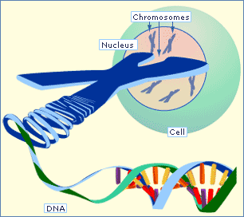
Unit 11: Genetics

7.14AC Heredity and Inherited Traits

Student Expectation
The student is expected to define heredity as the passage of genetic instructions from one generation to the next generation AND recognize that inherited traits of individuals are governed in the genetic material found in the genes within the chromosomes in the nucleus.

Key Concepts
- Key Concept 1: Traits of an individual organisms result from a hereditary process that passes genetic material from one generation to the next. The inherited traits of individuals are governed in the genetic DNA material found in the genes within chromosomes in the nucleus of previous generations.
- Key Concept 2: Genetic DNA material is inherited from both parents in sexual reproduction. Inherited traits include expressed external characteristics such as eye color and hair color, and internal characteristics such as blood type. Inherited traits are not affected by the organism’s surroundings.
- Key Concept 3: Heredity is the process by which characteristics are transmitted from parents to their offspring. The units of inheritance are genes and are stored within the chromosomes in the nucleus of a cell.

Fundamental Questions
- What is the hereditary process and why is it important to living organisms?

- How are external and internal characteristics transferred from one generation to the next?

- What role do genes and chromosomes play in the hereditary process?

7.14B Asexual and Sexual Reproduction

Student Expectation
The student is expected to compare the results of uniform or diverse offspring from sexual reproduction or asexual reproduction.

Key Concepts
- Key Concept 1: Traits of organisms are a direct result of two factors: the genetic material present in previous generations and the type of reproduction, sexual or asexual. Organisms that reproduce asexually produce uniform offspring. Organisms that reproduce sexually produce diverse offspring.
- Key Concept 2: In asexual reproduction, prokaryotic cells divide by binary fission, replicating DNA from the parent and producing uniform offspring. Organisms composed of eukaryotic cells can also reproduce asexually by forming spores, by budding, or by vegetative propagation.
- Key Concept 3: In sexual reproduction of eukaryotic organisms, the offspring receives some DNA from both parents resulting in unique combinations of dominant and recessive traits for each offspring.

Fundamental Questions
- What two factors directly affect the traits of an organism?

- What is the process of asexual reproduction? How does it produce uniform offspring?

- Why does sexual reproduction result in unique combinations of DNA in each offspring?

Unit 12: Genetic Variations & Adaptations

7.11A Dichotomous Keys

Student Expectation

The student is expected to examine organisms or their structures such as insects or leaves and use dichotomous keys for identification.

Key Concepts
- Key Concept 1: Populations and species demonstrate unique variations. Scientists use dichotomous keys as a tool to classify and identify organisms based on their traits and structures.
- Careful examination of the structures of animals and plants reveals distinct characteristics that can be used to classify and identify different species.
- Large amounts of information can be organized and classified using dichotomous keys. These keys rely on binomial classification of the distinct structures and characteristics of plants and animals to identify organisms.

Fundamental Questions
- What tool is used to classify and identify the vast number of living organisms from one another?

- How can dichotomous keys be used to classify organisms?

- What are the characteristics of a dichotomous key and how do you use it?

